**AN ONLINE SYSTEM TO LINK CITIZENS AND LAWYERS**

By

Wabuiya Luke Mugetha

105235

An Information Systems Project Proposal Submitted to the Institute of Management and Information Technology in partial fulfillment of the requirements for the award of Diploma in Business and Information Technology

**Faculty of Information Technology**

**Strathmore University**

**Nairobi, Kenya**

**June, 2019**

# Declaration and Approval

I Luke Mugetha Wabuiya declare that this project has not been submitted to any other University for the award of a Diploma in Business and Information Technology

Student Number: 105235

Sign: ________________________ Date: ________________________

Supervisor’s Approval: Dr. Bernard Shibwabo

Sign: ________________________ Date: ________________________

**ABSTRACT**

The criminal justice system is one of the most important systems in any economy. This is because the Law system has procedures and processes that control law enforcement hence providing justice in an economy. The criminal justice system is mainly controlled by government officials such as magistrates, judges and prosecutors, it is also controlled by lawyers who are all in general law practitioners. Though important, it has some flaws which prevent true justice from being provided to the citizens and civilians in a country. In an economy such as Kenya, the system has proven vulnerable in that the common civilian is unable to access good representation in a court of law in the event of conviction. This has led to delay in court rooms and overcrowding in prisons. The system will link lawyers and civilians together hence speeding up court processes and in general improving the law enforcement processes. The system will be developed via prototyping to enable fast development and increased contact with users so as to deliver what civilians and lawyers are lacking in the criminal justice system.

# Table of Contents

Declaration and Approval ii

Table of Contents iv

List of Figures vi

Chapter 1: Introduction 1

1.1 Background Information 1

1.2 Problem Statement 3

1.3 General Objective 3

1.4 Specific Objectives 3

1.5 Justification 4

1.6 Scope 4

Chapter 2. Literature Review 5

2.1 Introduction 5

2.2 Challenges Facing the Criminal Justice System in Kenya 5

2.3 Applications Related to this sector 6

2.3.1 Brighter Monday Kenya 6

2.3.2 App4Legal 6

2.3.3 CaseFox 7

2.4 Challenges Facing Existing Systems 8

2.5 Conceptual Framework 9

2.6 Conclusion 10

Chapter 3: Research and Methodology 11

3.1 Introduction 11

3.2 System Development Methodology 11

3.2.1 Requirements Analysis 11

3.3 Functional Requirements 12

3.4 Non-Functional Requirements 12

3.5 Tools and Techniques 13

3.5.1 MySQL 13

3.5.2 PHP 13

3.6 Deliverables 13

3.6.1 User Module 13

3.6.2 Administrators Module 13

3.6.3 Security 13

Chapter 4 System Analysis and Design 14

4.1 Introduction 14

4.2 Analysis Diagrams 14

4.2.1 Use case Diagram 14

4.2.2Sequence Diagram 16

4.2.3 Entity Relationship Diagram 17

4.2.4 Database schema 18

4.2.5 Data Flow Diagram 19

4.2.5.1 Level 0 Data Flow Diagram 19

4.2.5.2 Level 2 Data Flow Diagram 19

References 21

# List of Figures

Figure2.1: Brighter Monday (Mbugua, 2017 ) 6

Figure 2.2: App4Legal (Graham, 2019). 7

Figure 2.3: CaseFox (Graham, 2019). 8

Figure 2.4: CaseFox (Graham, 2019). 8

Figure 2.5: Conceptual Framework. 10

Figure 4.1: Use Case Diagram. 15

Figure 4.2: System sequence Diagram. 16

Figure 4.3: Entity relationship Diagram. 17

Figure 4.4: Database Schema. 18

Figure4.5: Level 0 Data Flow Diagram. 19

Figure 4.6: Level 2 Data Flow Diagram. 20

**List of Abbreviations**

|  |  |
| --- | --- |
| Admin | - Administrator |
| CSS | - Cascading Style Sheets |
| HTML | - Hypertext Markup Language |
| MySQL | - Structured Query Language |
| PHP | - Hypertext Preprocessor |

# Chapter 1: Introduction

## 1.1 Background Information

The criminal justice system is the set of agencies and processes established by a governments to control crime and impose penalties on those who violate laws within the country’s jurisdiction. The System is controlled by a band of attorneys, judges, prosecutors and officers. The prosecutors and attorneys (lawyers) who handle the cases in the criminal justice system have to be law practitioners and also have to be approved by the ruling law committee in a country. The law committee is a board of highly qualified lawyers who issue out the law licence to an individual practising law in a country after they have undergone the training and passed the qualifications (Duizend, 2017).

Most criminal justice systems including Kenya’s have five components in common;-law enforcement, prosecution, defence attorneys, courts and corrections, each playing a key role in the criminal justice process.

Law Enforcement- the Law enforcement has officers who take reports for crimes that happen in their areas. Officers investigate crimes and gather and protect evidence. Law enforcement officers may arrest offenders, give testimony during the court process and conduct follow-up investigations if needed (Lubale, 2012).

Prosecution**-**It is executed by a prosecutor. Prosecutors are lawyers who represent the government (not the victim) throughout the court process-from the first appearance of the accused in court until the accused is acquitted or sentenced. They are simply judges who represent the government in a court hearing (Lubale, 2012).

Defence Attorneys**-** Defence attorneys defend the accused against the government's case. They are either hired by the defendant or (for defendants who cannot afford an attorney) they are assigned by the court (Lubale, 2012).

Courts- Courts are run by judges, whose role is to make sure the law is followed and oversee what happens in court (Lubale, 2012).

Corrections-Correction officers supervise convicted offenders when they are in jail. They are simply officers who patrol jails under command of a warden (Lubale, 2012).

Having discussed the criminal justice system basics and components, we have the criminal justice process. This is how the criminal justice components work together to provide law fulfilment. The process starts with a Report in the event law enforcer sites a law being broken. An investigation then takes place to identify the suspects or actual law offender, upon collection of enough evidence a judge signs of on a warrant that allows the arrest of a particular individual who may have committed the crime. The arrested party is then set to go to court for prosecution before a jury whilst being represented by a defence attorney. In Court, the defendant is either found guilty or innocent where by upon innocence they are let go, in the event they are found guilty they are bestowed upon their penalty as the court wishes it. This occurs when a report has been filed by law enforcement (Lydia, 2018).

In other events charges may be pressed by a civilian party against a fellow civilian party. In this process there will not be prosecutors only two defence attorneys in court to resolve the conflict and in most cases the judge decides the outcome instead of a jury (Lubale, 2012).

As there are different, cases there are also different defence lawyers with different expertise in a particular field, cases for example divorce\marriage case lawyers are differently equipped as opposed to financial\ business case lawyers or even drug and probation based lawyers. There are types of lawyers to handle cases depending on their skill set. Some examples of lawyers are; Personal Injury Lawyer, Estate Planning Lawyer, Bankruptcy Lawyer Intellectual Property Lawyer, Employment Lawyer, Corporate Lawyer, Immigration Lawyer, Criminal Lawyer (Wong, 2015).

The problems in this sector prove the introduction of this web system will increase contact between lawyers and civilians, civilians will be able to judge which lawyers are better qualified and they will also get lawyers who are within the budget they set. For lawyers, they will be able to gauge cases civilians bring up and get clients with cases equal to their ability.

## 1.2 Problem Statement

The criminal justice system though under government supervision hosts some serious problems especially in Kenya. The problems dominating the criminal justice system include a lack of knowledge by groups such as the youth on the procedures to take and processes to follow once they have been convicted for a crime or charges have been pressed against them which has also caused a backlog of cases in the courts brought about by the inaccessibility of lawyers to the public, this has led up to a crime committed today is set to be heard in court a year from now (Otieno, 2018).

Furthermore we have a lack of experience in law practitioners who claim to be certified lawyers yet the number of cases choked in Nairobi courts has far exceeded previous years. In addition to that we have lawyers who find it hard to acquire clients willing to take on fresh lawyers from the academies. The level of poverty in Kenya has also interfered with the ability of the common citizen to acquire adequate representation in court.

In order for the criminal justice system to be efficient such problems must be purged. Linking uninformed groups with lawyers can greatly improve the speed at which these processes take place as they are guided. In simpler terms if we can bridge the gap between lawyers and citizens some problems will quickly disappear.

## 1.3 General Objective

The general objective of this project is to create a web system that makes it easier for citizens to get lawyers and lawyers to get in touch with clients and more experienced lawyers. It will also allow lawyers in general to get in touch with law firms

## 1.4 Specific Objectives

1. To analyse the various types of cases that civilians go through.
2. To investigate the existing web system and analyse their problems.
3. To develop the web system to link lawyers and civilians while providing an environment for new lawyers to get experience.
4. To test the web system and ensure users compatibility.

## 1.5 Justification

The system will help civilians find capable lawyers to handle their particular type of cases. The civilians will also be able to build a good rapport (relationship) with their lawyers hence a level of trust. Civilians who are unable to afford good representation will be directed to more affordable lawyers or even pro bono lawyers who are still qualified to the case specifications.

The system will enable lawyers starting out to get clients with cases befitting their level of skill. The lawyers will acquire experience as a result. The lawyers starting out will also be able to get in touch with highly experienced and qualified lawyers to get training and experience under pressure of cases.

1.6 Scope

The web system will be accessible to all areas with internet service. It will only be accessible to smart devices. The website will only deal with Kenyan cases, civilians and all lawyers practicing law in Kenya.

# Chapter 2. Literature Review

## 2.1 **Introduction**

A literature review is a documented article, which includes the current knowledge including substantive findings, as well as theoretical and methodological contributions to a particular topic. This chapter will entail previous systems, their challenges and gaps/opportunities in the field of online systems that involve lawyer civilian interactions and what can be done to fill those gaps. The article will seek to answer the question, what is missing in existing systems and what makes ours so different.

## 2.2 Challenges Facing the Criminal Justice System in Kenya

Kenya has a week criminal justice system, in that it questions the meaning of rendering justice to the citizens of the country this is due to the host of challenges it faces. The criminal justice system is yet to be modernized and technology to be put to good use in this sector. Civilians and lawyers both face challenges when it comes to matters of law in the country. Several Citizens have encountered the issue of not being able to find lawyers at all. As it turns out finding lawyers in online forums is difficult as there is a lack of a common forum where lawyers are incorporated. Due to this occurrence lawyers are searched for in physical offices. The gap is clear since there might not be enough time for the lawyer to deal with every client in a closed office and not all civilians can get access or an appointment in this situation (Otieno, 2015).

Furthermore, Civilians also have no clue whether a particular lawyer can win their cases or not this has resulted in several defence attorneys choking cases in courts resulting into civilians receiving sentences, hence the need to know other people’s opinions on a particular lawyer. Civilians also find it hard to pay lawyers hence the need to be acquainted with lawyers who do Pro bono cases.

Lawyers also face their distinct problems. For one, young lawyers starting out find it hard to know cases and get clients, they also need mentors who will show them how to deal with cases and get into law firms. Due to these problems in the sector the introduction of this web system will enable civilians to have more contact with lawyers, they will also be able to choose good lawyers depending on the lawyer’s ratings and record of cases won and they will also get affordable lawyers within their set budget. For lawyers they will be able to get easy cases within their capabilities. They will also be able to reach out to more experienced lawyers as mentor who will help train them and enrol them into law firms (Garland, 2001).

## 2.3 Applications Related to this sector

## 2.3.1 Brighter Monday Kenya

Brighter Monday Kenya is a web system based in Kenya created to show job vacancies created by users signed up and users can still apply for these jobs. It has a legal section where lawyers can take up jobs posted by people in need. Using your smartphone or laptop, open the link to the site set the filter to legal sector then one may select either set a job alert(for civilians seeking lawyers) or apply for a job(for lawyers) already posted. The challenge with Brighter Monday Kenya is the client seeking a lawyer is not sure of the skillset the lawyer will offer. The case may be too demanding for the lawyer and the client might also overpay the lawyer for an easy case. It is also limiting making it a race for lawyers to secure a job alert when many lawyers are logged on (Mbugua, 2017).

# 

Figure2.1: Brighter Monday (Mbugua, 2017 )

## 2.3.2 App4Legal

App4Legal is an intuitive, law practice management solution that allows a lawyer to focus on the creative, problem-solving aspects of a lawyers work. It is designed by lawyers for lawyer users, it shows lawyers different scenarios depending on a case a lawyer has selected or typed. App4Legal is a web-based solution available on-server or on-cloud and supported with a mobile application iOS & Android. Whether you work as solo practitioner, in a law firm or in an in-house legal department. App4Legal has a homepage where new members register and members enrolled log in. It presents a table showing types of cases where members type the case they are handling and actions being taken to proceed with the case. The challenge facing App4Legal is it does not provide any civilian support, then it takes civilians to be an object in the system their input is not considered necessary. In simpler terms App4legal is an online web system for managing a law firm where only clients registered by their lawyers can access (Graham, 2019).

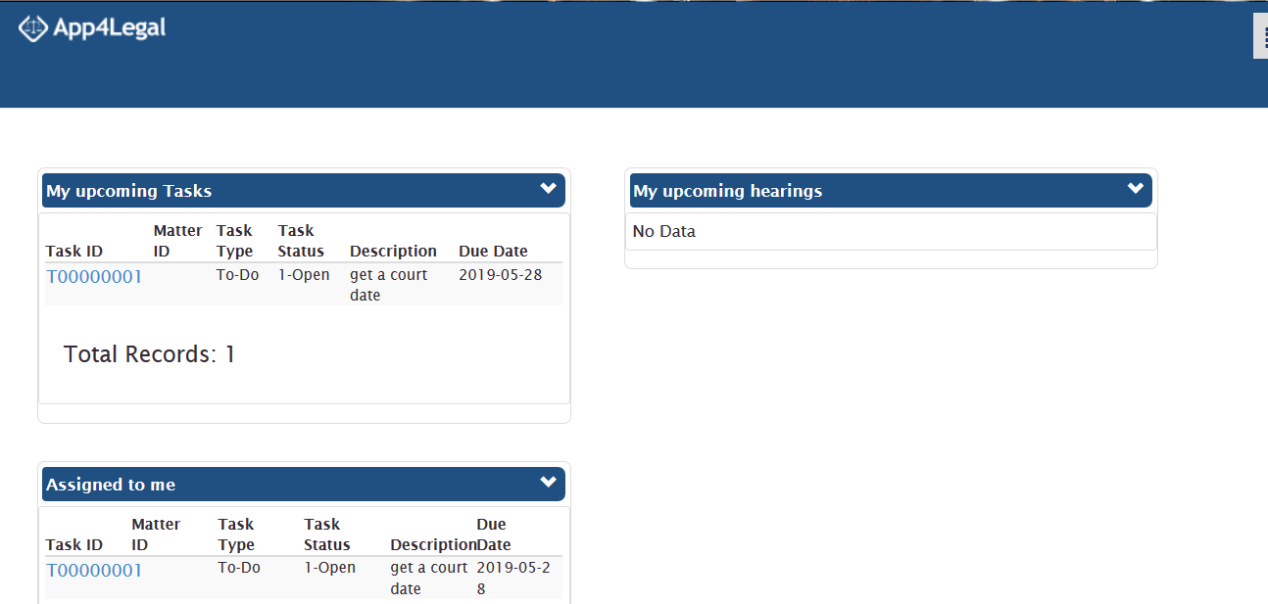

Figure 2.2: App4Legal (Graham, 2019).

## 2.3.3 CaseFox

CaseFox offers a cloud based software that is designed for attorneys, CPAs and other professionals with their practice management, billing, invoicing, trust fund management, case document management, client management, tracking billable time, expenses and payments. CaseFox is designed to help virtual firms, psychiatrists, virtual lawyers and therapists. For lawyers it allows them to keep a detailed file of their cases of each client whom the lawyer personally registered. For these cases it tracks billable hours, late payments and priority cases. The challenges biggest challenge facing CaseFox is that it is not cost efficient. CaseFox is also unable to integrate into the problems facing Kenya effectively. It does not allow civilians users to search for lawyers befitting their need or help starting lawyers get clients (Graham, 2019).

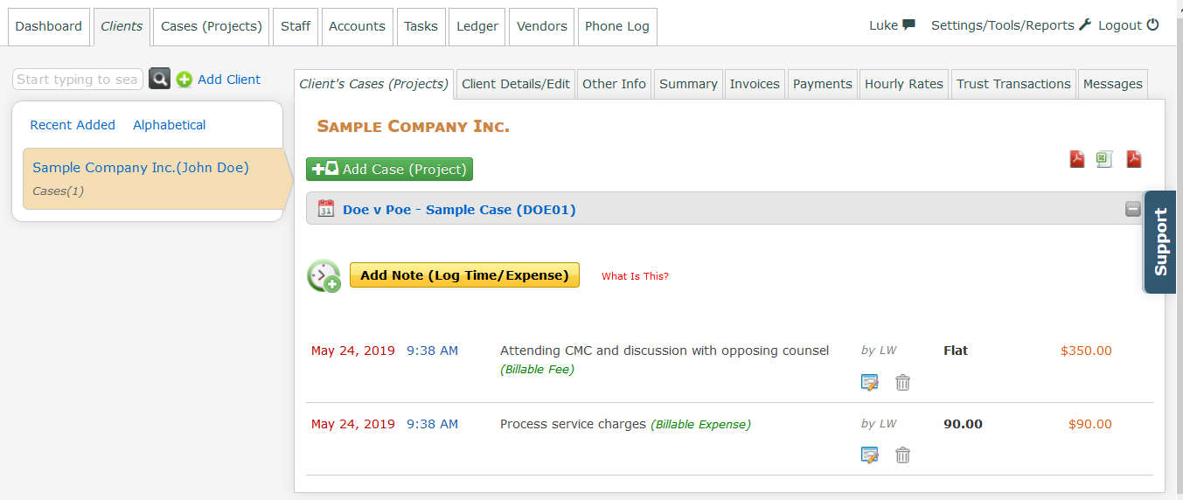

Figure 2.3: CaseFox (Graham, 2019).

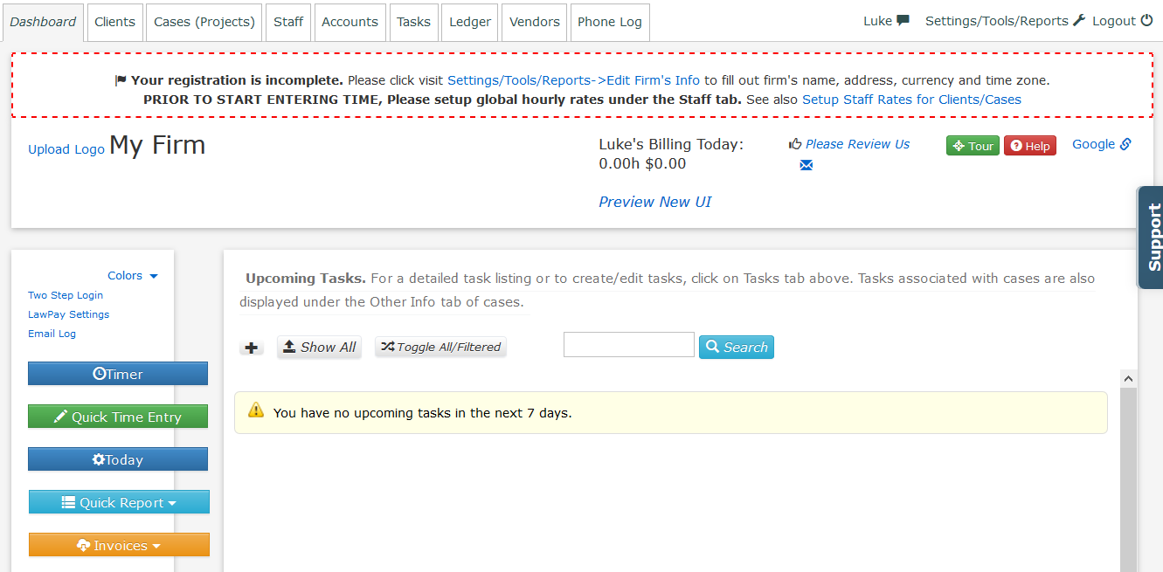

Figure 2.4: CaseFox (Graham, 2019).2 1 1

## 2.4 Challenges Facing Existing Systems

The existing system have tried to solve existing issues but are still lacking this is because they are not addressing all aspects of the criminal justice sector. For one they consider civilians as objects in that they do not work with them to get what it is they are looking for, which is a lawyer who is qualified for their particular case at an affordable rate. Most system also lack to see that lawyers also need help especially those new to the system, these lawyers need experience which can only be acquired by getting clients with cases which are not too complicated and also by being mentored by highly experienced lawyers. These lawyers can also be enrolled in teams of lawyers hence being introduced to law firms.

The existing systems also lack cost efficiency which is vital in a country such as Kenya where not all civilians are at par with the gross domestic product. The existing systems also take advantage of users’ lack of knowledge on how these legal systems work hence overcharging them. These users require a system that gives them awareness. The existing systems are also non localized they are not directly integrated into Kenya’s criminal justice system hence may refer to law firms abroad even lawyers abroad.

## 2.5 Conceptual Framework

The user (civilians and lawyers alike) can access the login page via smart devices. They will login or register if they have not previously accessed the system. If the user is a civil citizen, they will select the type of case they are facing in court. They will type a brief description of their situation in that type of case. The system will analyse their case and search for lawyers suitable to the task.

The system will judge the lawyer’s capability to handle the user’s case in terms of comments posted by other users and several social media and internet web pages, the system will also take into account the number of cases the lawyer has won in terms of percentage of cases won (track record). The civilian user receive the best of what the system has deduced out of the search. Once there they can view the lawyer’s credentials such as email, phone number and office location. In the case of the user being a lawyer the user. They will be required to select which service they want such as mentorship or joining a law firm.

The diagram below briefly describes the devices which will be able to access the system such as a smartphone and the laptop and how the information will travel to the server via the modem.

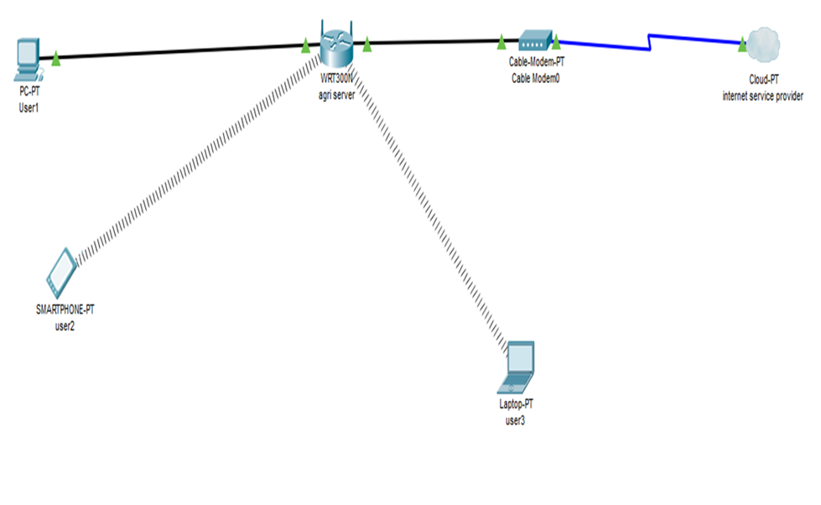

Figure 2.5: Conceptual Framework.

## 2.6 Conclusion

The main problem is creating a bridge between lawyers and civilians while also creating links between lawyers and lawyers to address the issue of experience hence diminishing the gap in Kenya’s criminal justice system. As we can see the existing systems set in place do not address the criminal justice sector as a whole but divide it into section leaving other sectors out, others cannot serve Kenyans all together due to lack of local familiarity.

The Law community linking system will address all these issues it will be able to allow civilians to log in select their case category and type their case specifics, the system will then search for suitable lawyer taking into account their experience, cases won, the budget of the civilian user. It will also have lawyer users who will be taking clients and also for beginner lawyers it will provide them with links to law firms and mentorships from experienced lawyers where they will be titled associates. This will be a clear resolve for Kenya’s criminal justice system.

# Chapter 3: Research and Methodology

## 3.1 Introduction

This chapter presents the methodology that will be used in this project and the requirements necessary for the system to perform its tasks. The methodology to be used for this project is prototyping. Prototyping is especially useful when providing proof that something can indeed be done in terms of systems and strategies. Prototyping is designing and building a scaled down version of the desired system.

## 3.2 System Development Methodology

As discussed prototyping is designing and building a scaled down but functional version of the desired system, this provides the possibility of developing a system that meets user’s requirements. Prototyping also enables the system required to be quickly developed and delivered to the users. Prototyping methodology is used for certain projects and will eventually be discarded after the project is completed. Prototyping as a methodology is implemented by quickly creating prototypes and there after gathering feedback from end users to check whether it qualifies to be large scaled, this is valuable so as to get a better understanding of the actual needs of the normal civilian before the system is fully developed and delivered to the general public.

Furthermore, the user might not clearly understand what they clearly need in the system therefore as prototyping has the objective of developing a system rapidly and to understand user requirement it gives the option of developing a better system requirement definition in the process. Hence, the prototype focuses on experimenting with the user requirements before modifications are made therefore meeting the user’s standards.

## 3.2.1 Requirements Analysis

In the planning phase, joint application development will be conducted to amass and understand the system needs and user requirements. During these sessions tools such as Microsoft Visual Studio .Net will be used to generate a user interface to verify user requirements.

After gathering user requirements from the joint application development session we will make an analysis and try to implement each and every module based on the users requirements gathered.

In designing the prototype stage, the work will be to assemble every module that had been implemented in the preceding step to complete a finalized system prototype. Prototypes will be unveiled to the end users who will utilize them for testing and evaluation purposes. At this time they will provide feedback to the designated designers who will look at the drawbacks and revaluate their approach as to how they will build the system. As per the requirements of the end users derived from feedback and continuous testing the prototypes will be modified until the end users requirements have been meet.

The last phase will be implementation where developing the finalized module within the time frame stipulated and delivering t to the end users.

## 3.3 Functional Requirements

1. The system will prompt the user to specify whether there are a lawyer or a civil citizen.
2. The system shall let civilian users select the type of case they are facing.
3. The system will prompt civilian user to enter a brief description of their case or charges that have been pressed against them.
4. The system will then retrieve relevant data on preferable lawyers to handle the user’s specified cases.
5. The system will retrieve clients relevant to the lawyers if they are in search for clients.
6. The system will retrieve lawyers seeking assistants or associates if the lawyer user is in search of mentorship.
7. The system will also retrieve information on available law firms

## 3.4 Non-Functional Requirements

1. Security of user information and also personal security through the verification of users-email verification and encryption of passwords.
2. It is a user-friendly as a guide section will be include on the platform.
3. Availability will be key as one will simply use a link to access the system.
4. Platform compatibility is covered as all devices with internet access can access the web system.

## 3.5 Tools and Techniques

## 3.5.1 MySQL

MySQL provides an implementation of SQL database suited for small to medium web pages. The database is free and open with a commercial license available.

Common applications for MySQL include PHP and java based web applications that require a database storage backend. Many applications using MySQL are geared towards the LAMP stack (Linux, Apache, MySQL and PHP).

## 3.5.2 PHP

PHP is a server-side scripting language usually written in HTML context. A PHP script is not sent directly to a client by a server instead it is parsed by the PHP binary or module which is server-side installed. HTML elements in script are left alone but PHP code is interpreted and executed. PHP code in a script can query databases, create images, read and write files, talk to remote servers making the possibilities endless. The output from PHP code is combined with the HTML in the script and the result is sent to the user’s web browser therefore it can’t tell the user whether the web browser uses PHP or not since the entire browser sees it as HTML.

## 3.6 Deliverables

## 3.6.1 User Module

The user can be able to create an account and log into their account. The user will also be able to select a type of case they are facing and write a brief description of the charges.

## 3.6.2 Administrators Module

The administrator can update the database by adding or removing users.

## 3.6.3 Security

The user’s information will be taken to be confidential and thus the system will ensure that by use of access levels which will also protect the administration.

# Chapter 4 System Analysis and Design

## 4.1 Introduction

Systems are implemented to curb gaps in society and solve problems facing people. This chapter will list all actions or events typically defining the interaction between a role and a system to achieve a specific goal.

## 4.2 Analysis Diagrams

## 4.2.1 Use case Diagram

This is a graphic depiction of a system’s behaviour or functionality under various conditions as the system responds to demands from users (TechTarget, 2007)

In the use case diagram below, we have four actors who will be interacting with the system. The actors include; civilians, superior lawyers, associate lawyers and the administrators. The civilians members being troubled individuals with cases pending in court will log into the system after registering and select the type of case they have set for trial in court there after they will write down a brief description of the case. The system will take this information and auto generate suitable lawyers for the citizens’ particular case. The citizen is then required to select a lawyer they see fit depending on the rating and win rate of cases in court. The lawyer selected will then receive a potential case. The administration will handle maintenance on the system and also key in scouted lawyers into the system, they will also oversee updates to system data and software. Superior lawyers in the system are experienced lawyers who rank highly in terms of stature, they will receive cases from civilian members and accept them or lead them off to their associate lawyers. Associate lawyers are lower grade lawyers who lack experience to be classified as superior lawyers, they will take up cases from superior lawyers and learn from the expertise of a superior lawyer.

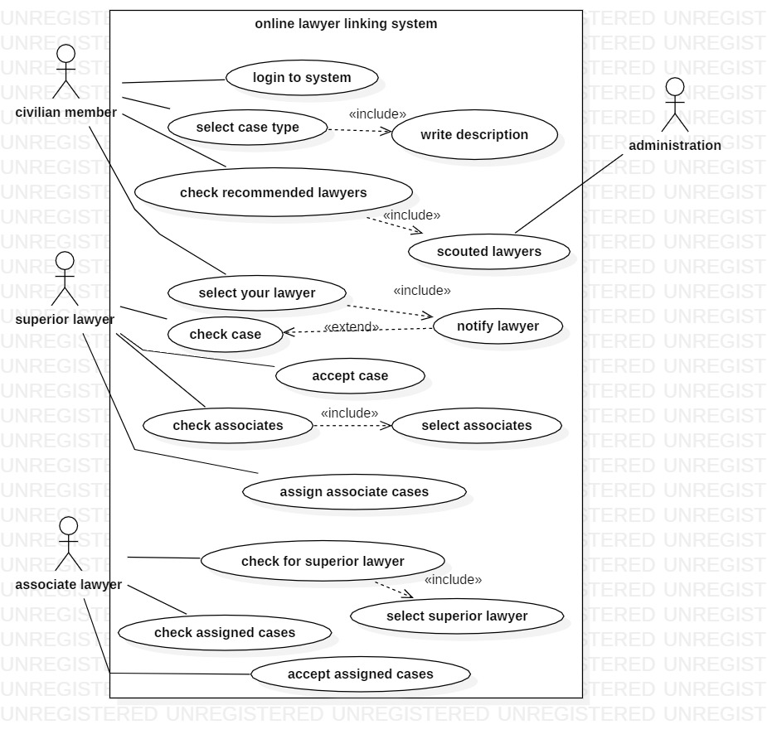

Figure 4.1: Use Case Diagram.

## 4.2.2Sequence Diagram

Civilians key in their case details into the system. The system works to provide a suitable lawyer for the civilian. The superior lawyer selects the cases the want to do and decline if they do not want to do it. Superior lawyer seeking office help also get requests from associate lawyers, they then lead off some cases to the associate lawyers and supervise their work. The associate lawyers send requests to superior lawyers and after being accepted by the superior lawyers they receive cases and supervision from the superior lawyers.

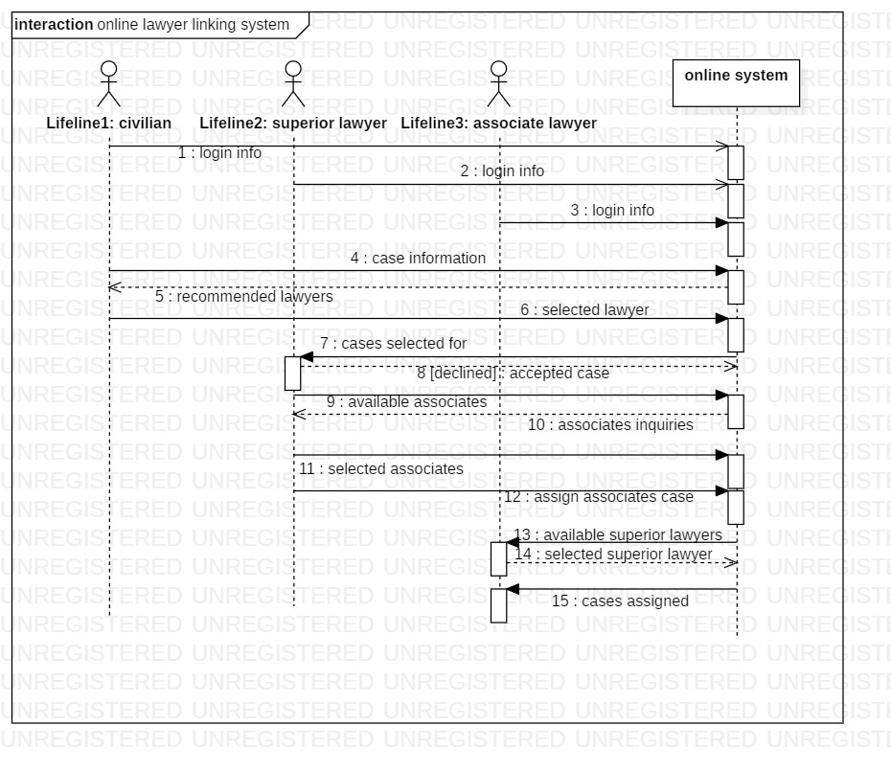

Figure 4.2: System sequence Diagram.

## 4.2.3 Entity Relationship Diagram

An entity relationship diagram (ERD) is a graphical representation of an information system that depicts the relationships among people, objects, places, concepts or events within that system (Rouse, 2018).

Figure 4.3: Entity relationship Diagram.

Associate lawyer

Has

Hass

Superior lawyer

Civilian

Has

Case

## 4.2.4 Database schema

The database that was used for the system is MySQL database. The entities in the database are users, civilian members, cases, superior lawyers and associate lawyers. The users has a member type, an Id, full name, phone number and an email address which will be similar to the one in their particular member class. The cases have a case Id, a case type, case information and the civilian users’ Id. The superior and associate lawyers have their users’ information and in addition a case type and case Ids.

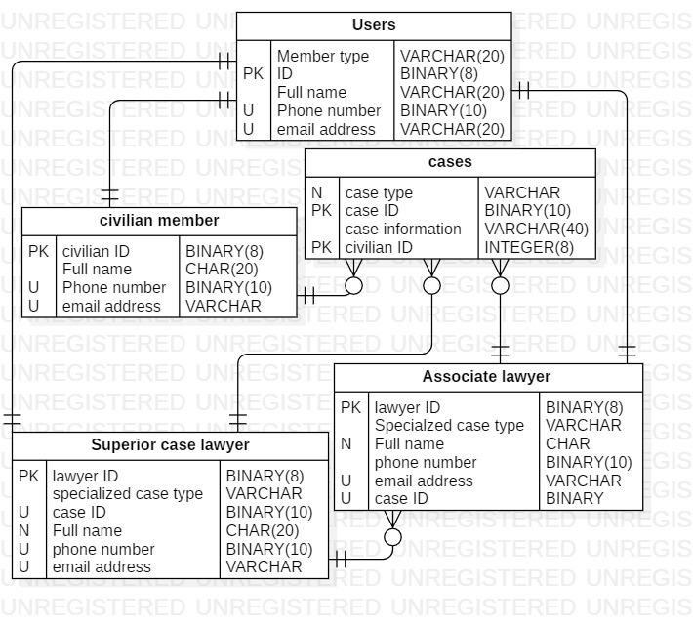

Figure 4.4: Database Schema.

## 4.2.5 Data Flow Diagram

## 4.2.5.1 Level 0 Data Flow Diagram

This is in engineering is a diagram that defines the boundary between the system, or part of a system, and its environment, showing the entities that interact with it.

The Data flow diagram below simply describes how a civilians cases are floated to the lawyer community and how the lawyer community confirm and relay information back to the civilian community.

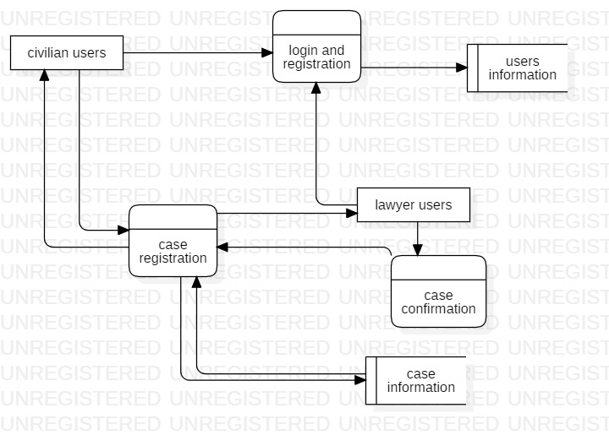

Figure4.5: Level 0 Data Flow Diagram.

## 4.2.5.2 Level 2 Data Flow Diagram

This represents a system’s major processes, data flows and data stores at a higher level. This diagram shows how the civilians’ cases go through to the superior and associate lawyers respectively while superior lawyers take associate lawyers under their wing and solve cases together.

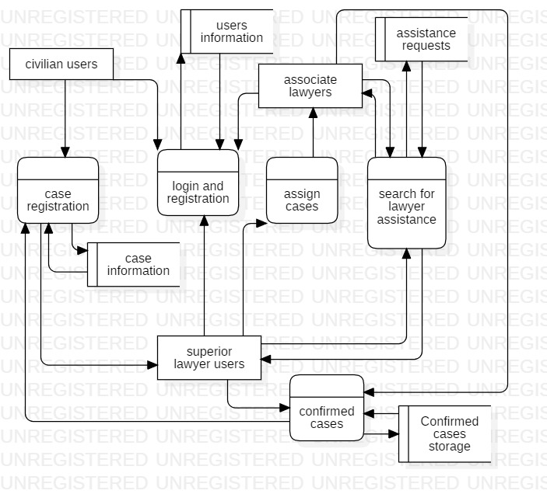

Figure 4.6: Level 2 Data Flow Diagram. 1

# References

Duizend, V. (2011, July 7). ModelTime Standards for State Trial Courts. Retrieved from NCSC:<https://www.ncsc.org/ServicesandExperts/Technologytools/~/media/Files/PDF/CourtMD/>

Dorothy, O. (2018, February 2) Daily nation. Retrieved from Nation Series: [https://www.nation.co.ke/authors/1959272-2835180-6keuqbz/](https://www.nation.co.ke/authors/1959272-2835180-6keuqbz/index.html)

Garland, D. (2001, March 13) Challenges Facing Criminal Justice System in Kenya. Retrieved fromGoogleBooks: <https://books.google.co.ke/books/about/The_Culture_of_Control.html>?

Graham, S. (2019, January 17) Court Applications For The World. Retrieved from CapTerra:<https://www.capterra.com/p/121682/CaseFox/>

Lubale, G. (2012, August 22). Constitution and Governance. Retrieved from CGC: <https://gabriellubale.com/constitution-and-governance-course/>

Lydia, A. (2018, July 7). Criminal justice reforms: issues and options for Kenya. Retrieved from ICJ: <https://icj-kenya.org/news/latest-news/184-criminal-justice-reforms-issues-and-options-for-kenya>

Mbugua,D (2017, May 2).About a Brighter Kenya. Retrieved from Brighter Monday Kenya:<https://www.brightermonday.co.ke/jobs?>

Wong. B. (2015, June 17). Caseflow. Retrieved from LegalZoom: <https://www.legalzoom.com/types-of-lawyers>